The Official
TOME
Starter Pack

Not everything with feathers is a rat.

Tips For Convincing Your Floor

- Take advantage of mandatory floor meetings. Promote TOME at all of them!

- Use the verses that inspired Shroud and Bolt to create the first TOME:

Acts 2:44-46
And all those who had believed were together and had all things in common; and they began selling their property and possessions and were sharing them with all, as anyone might have need. Day by day continuing with one mind in the temple, and breaking bread from house to house, they were taking their meals together with gladness and sincerity of heart.

Acts 4:34
For there was not a needy person among them, for all who were owners of land or houses would sell them and bring the proceeds of the sales and lay them at the apostles' feet, and they would be distributed to each as any had need.

- Use numbers and dollar figures. (page 9)

- Talk to each member of your floor individually.

- Put together a team of TOMEgnomes, and give them each a list of people to talk with.
- Ask for book pledges. People will want to keep their books until after finals, but ask them to commit to give the books to TOME as soon as they're finished. Take pledges on index cards.
- Catch people before they sell their books back. This is critical! Talk to them every semester; they'll forget.

- Be prepared to counter objections with gentleness and respect.

“What's in it for me? I'm graduating!”
- This is a chance to invest in the floor that's given a lot to you in other ways.
- As Christians, we are to called give without expecting others to return the favor.

“I need the money.”
- TOME is an investment that pays far better returns than the textbook buyback.
- Some people really do need the money. Do not subject them to undue pressure or ridicule.

“I want to keep this book.”
- You can loan it to TOME and get it back when you graduate. Meanwhile, your friends get to use it.

- Use clever propaganda. Because of the not-so-public nature of TOME (page 11), try to use posters that will remind your floor about TOME but won't make much sense to those who don't know what it's about (page 12).

- You know your floor better than we do. Market TOME to them!

Getting Started

Once a floor TOMEkeeper has been appointed, you still need several things to get your floor's TOME up and running.

- Storage space. We recommend a bookshelf of some sort in the TOMEkeeper's room. This has several advantages over a centrally located storage location:
- The TOMEkeeper needs computer access (to use the database) to check books in and out.
- Having the books in the TOMEkeeper's room discourages people from just taking books (“It's only for this afternoon, I promise!”), forgetting to ever return them, and leaving you with no record of where they went.
- The TOMEkeeper's room can be locked to prevent theft.
We recommend boxing the books and locking them the floor's storage closet during the summer.

- A stamp. The 41 TOME stamps the inside cover of all the books in the collection with a custom stamp from stamp-connection.com. It looks kind of like this:
41 TOME
Property of
___________
Originator
___________
ID
___________

Of course, you don't have to use this exact method, but it has worked well for us. One way or another, each book must be marked with its unique database ID number. This is the only way to identify and keep track of books.
The stamp clearly indicates which TOME the book belongs to, which will be important when the interTOME loan system kicks in. Also, it tells you whether the book is a permanent donation. We put TOME under “Property of” if the book stays with us, and the donor's name if it does not.

- A team. The TOMEkeeper can't do it alone. Finding people to help out during the crunch times (beginning and end of the semester) and also to help manage other aspects of operation (such as selling the old books on half.com) is essential to success. Just let us know if we need to create user accounts for others on your floor.
Using TOME

Once you have been added to the system, you can access it at the following URL:
http://dorm41.org/tome

Log in with your username and password and you will arrive at the front page of the TOME system.

Semesters
Many things in the database revolve around which semester a particular item is associated with. The system as a whole has a default semester that can always be seen in the upper right-hand corner of the screen. New entries of any sort will always default to using this semester. If you wish to temporarily override the system default semester, you can do so from the User Preferences screen.

Adding a book to your floor's TOME
- Click “Add TOME Book” on the top menu bar
- Fill in the ISBN from the back of the book
- Put the donor's email address in the Originator field
- If the donor wants the book back when they graduate, choose which semester the book should expire at the end of
- Add any special comments about the book such as “Front cover has water damage”
- The library should already point to your floor
- Click “Add TOME Book”
- You will be redirected to a page containing all the information the system has about the book you just added. The most important part of this right now is the newly generated book ID number. MARK THE BOOK WITH THE ID! And do it right away too, otherwise you'll forget and never find the book again.

The TOME system will not let you add a book unless it knows about the ISBN beforehand. If you try to add a book TOME does not know about, it will direct you to a page where information about that book can be filled in. This same page can also be used by following these instructions:

Searching
To search for a book, go to the home page of the TOME system. From there you can either search by general book information or by class.

Class Information
After selecting a class from the home page, you will be taken to a page with information about that class. Each book for the class has the following information:
- General book information
- Whether the book has been marked as usable
- When the book's usable status was last verified
- Who changed the entry last
- Any comments about the verification (where the information about a book's usability came from should be listed here)
- How many books are available in the library
When you find new information regarding the usability of books for classes, please update this page with the latest information. This data will be shared among all the TOMEs on campus, so with everyone working together, we should be able to maintain a very accurate listing of what books are needed for what classes. The only place to find official information from the university about what books are needed for what classes is at the bookstore's website: http://www.efollett.com/.

This page also has an area for general comments about the class. Books can be associated with a class by entering the book's ISBN number into the form on the bottom of this page.

Find Orphans
Keeping books associated with classes is essential. If a book is allowed to stay in the collection without any record of what class it is for, there's no way of knowing if it goes out of date or becomes useless. This page will generate a report showing books that are in any TOME but have not been associated with a class. Every TOMEkeeper should work to keep this list empty at all times.

Find Useless
Once all of the books have been associated with classes, this page will be able to generate a report showing books that are no longer useful in any classes. These books should be sold on Half.com as soon as possible, while they still have value.

Making a Checkout
Books can be checked out (or reserved) from the ISBN View page. Simply fill in the patron's email address and semester the checkout is for and click “Checkout.”

Fulfilling A Reservation
Reservations can be filled from the Semester Report page. Just select the book ID and click “Fill Reservation.”

User Preferences
Click on the User Preferences link at the bottom of any screen to access the settings for your user. From here you can change username (it is case sensitive), email address, password, and notification preferences.
Numbers

- The first TOME was started in fall 2003 by Shroud and Bolt
- The TOME system has (as of Fall 2006)
  - 1,058 books in the database
  - 823 books in the current collection
  - 946 checkouts since the beginning of the system
  - 368 checkouts for the fall semester of 2006
- Assuming each book is worth $50 (a very conservative estimate)
  - $18,400 saved this semester
  - $47,300 saved since the beginning of TOME
  - $52,900 worth of books have gone through the system

Policies

These are the policies that have worked well for several TOMEs. You're free to change these as you see fit for your floor, but keep in mind that we've been doing this for years, and we know they work.

- Everyone on the floor is free to borrow from TOME, whether or not they have donated books into the system.
- However, abuse of the system (damaging books, not returning books, etc.) will result in a revocation of borrowing privileges.
- Only members of the floor are allowed to borrow from TOME. And no, it doesn't count to borrow a book for a friend.
- All first time borrowers need to sign a borrower agreement. See page 13 for an example.

TOME relies on the honor system. We trust people by default.
A Note on Confidentiality

We do not believe that we are doing anything even close to wrong legally or ethically, we are not violating any policies, and we have RD approval for TOME. However, we still prefer that TOME stay “underground.” The book store probably wouldn't like us if they knew we existed, and that's a battle we'd prefer not to fight.

With this in mind, please make it clear to people on your floor that TOME stays on the floor.

Please also note that the bookstore's contract with the university restricts competitors' printed advertising. To be safe, do not put anything explicit on signs, banners, door hangers, etc. Instead, try something fun, like this...

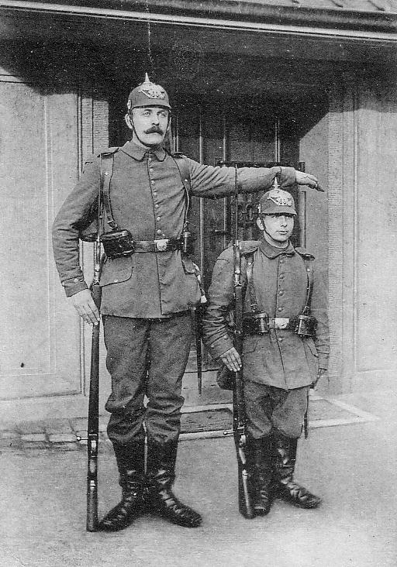
TOME

The beginning of something big
TOME Borrower Agreement

I understand that textbooks I borrow from TOME are not mine. Therefore, I will treat them with respect and care. I will prevent damage to them, including, but not limited to
- Torn pages
- Cover damage
- Food and water damage
- Writing and highlighting

I agree to pay to replace any textbooks that I damage or lose.

_____________________________________________________  Borrower Signature | _______________________  Date
_____________________________________________________  Approved by TOMEkeeper | _______________________  Date

TOME Borrower Agreement

I understand that textbooks I borrow from TOME are not mine. Therefore, I will treat them with respect and care. I will prevent damage to them, including, but not limited to
- Torn pages
- Cover damage
- Food and water damage
- Writing and highlighting

I agree to pay to replace any textbooks that I damage or lose.

_____________________________________________________  Borrower Signature | _______________________  Date
_____________________________________________________  Approved by TOMEkeeper | _______________________  Date

